Elementary / Middle School Project
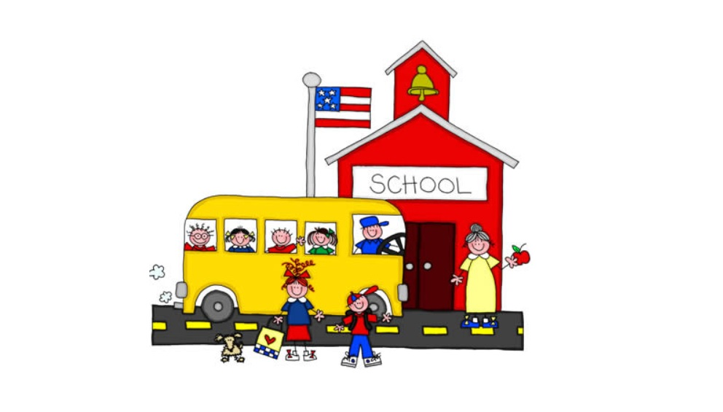

Name
School Grade
School Project Background
The West Virginia Interstate Fair & Exposition School Project is an opportunity for students to display the hard work and determination needed to excel in school and in life. Through this project you can show what you have learned, either at school or during at home learning and virtual learning.

Project Guidelines
1. Identify a topic or subject for your project.
2. Complete the Planning Your Project section (steps 1-3) of this guide by discussing and researching your topic or subject, by planning and completing at least two learning experiences and by planning and completing at least two leadership/citizenship activities.
3. Complete the Conducting Your Project section by identifying and completing three areas of interest and two activities within each area.
4. Complete the Reporting Your Project section of this guide.

Name
Age (as of January 1st) Grade
School Name
Advisor
Subject/Topic you’ve chosen to present:

Planning Your Project
Step 1. Let’s Begin (Check off what you plan to do.)
- Discuss your ideas with parents, teacher or your project leader.
- Check school books or library books about your topic
- Visit websites that provide information about your topic

Step 2. Learning Experiences
Choose at least two learning experiences for the list below. Write them in the table below.
- Attend a class, zoom meeting, workshop on a topic related to your subject.
- Organize a class activity on this subject.
- Prepare a project (Science, Social Studies or Math) to be displayed a school, county or fair level.
- Participate in county science, social studies or math fair.
Learning Experience | Date Completed | Project Advisor’s Initials
Example: Showed my science project at the county science fair. | 3/24/21 | KC
Step 3. Leadership/Citizenship Activities
Choose at least two leadership/citizenship activities from the list below. Write them in the table below.
- Assist in setting up and or cleaning up for a class.
- Help someone with their project.
- Encourage other students to take a project to the fair.
- Teach someone something you learned about your project.
- Prepare and exhibit a display at the WV Interstate Fair.
- Give advice to other students who are planning to take an exhibit to the WV Interstate Fair.
Leadership/Citizenship Activity | Date Completed | Project Advisor’s Initials
Example: Helped Jaxson with his science project. | 3/24/21 | KC

Conducting Your Project
Projects are broken down into areas of interest. These are specific things you might want to do a project on. In the space provided on the next page, identify at least two areas of interest, with at least two activities per area.
Ask your project advisor to initial next to the date each one is completed.

Example: My first area of interest is to do a social studies project on family history.

Activity 1: Look online to see if I can find my family genealogy.

Activity 2: Talk to my parents about my family tree.

Activity 3: Talk to a librarian or genealogist to find out how to do a family history.

Activity 4:

Date Completed: 2/15/21

Project advisor’s initials: KC

Conducting Your Project (Continued)
My first area of interest is to
Activity 1:

Activity 2:

Activity 3:

Date completed: Advisor’s initials
__________________________________________________________
My second area of interest is to
Activity 1:

Activity 2

Activity 3:

Date completed Advisor’s initials __________________________________________________________
My third area of interest is to
Activity 1:

Activity 2:

Activity 3:

Date completed: Advisor’s initials
Reporting Your Project
In the space below summarize what you did and learned. Then arrange for a project review with your project advisor, who should review this completed project guide with you. Such evaluations help you assess what you learned during your project.
Your Summary

To register a project for the West Virginia Interstate Fair & Exposition, simply go to www.wvinterstatefair.org and complete the school project booklet. Print out your completed booklet and bring it and your project display to the fairgrounds to register on Sunday, June 20, 2021.

